#### Q1. Print the following pattern for the given number of rows.

##### **Pattern for N = 4**

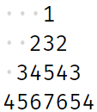

#### The dots represent spaces.

##### **Input format :**

Integer N (Total no. of rows)

##### **Output format :**

Pattern in N lines

##### **Constraints :**

0 <= N <= 50

##### **Sample Input 1:**

5

##### **Sample Output 1:**

1

232

34543

4567654

567898765

##### **Sample Input 2:**

4

##### **Sample Output 2:**

1

232

34543

4567654

Q2.Print the following pattern for the given number of rows.

##### **Note: N is always odd.**

##### **Pattern for N = 5**

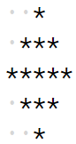

#### The dots represent spaces.

##### **Input format :**

N (Total no. of rows and can only be odd)

##### **Output format :**

Pattern in N lines

##### **Constraints :**

1 <= N <= 49

##### **Sample Input 1:**

5

##### **Sample Output 1:**

*

***

*****

***

*

##### **Sample Input 2:**

3

##### **Sample Output 2:**

*

***

*